**SALES MONITORING AND SALES MANAGEMENT**

**SYSTEM WITH SMS NOTIFICATION OF**

**ZARATE PIGGERY FARM**



A Capstone Project

Presented to the Faculty of Computer Studies Department

Holy Child Central Colleges Inc.

In Partial Fulfillment of the Requirements

for the degree of Information Technology

By

Borbon, Ma. Isabel F.

Celestial, Kyle Ivan C.

Celestial, Ronilyn M.

Gegrimos, Kent John G.

August 14, 2023

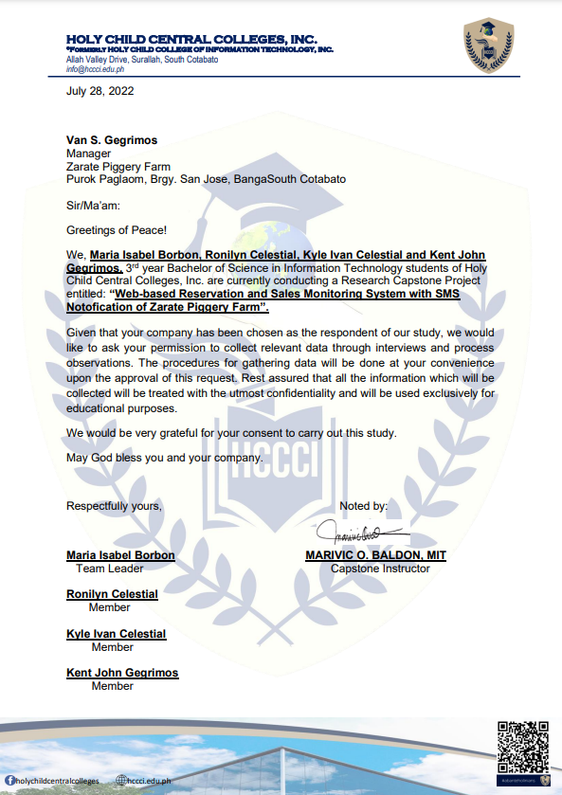

**GRAMMARIAN CERTIFICATE**

**ACKNOWLEDGMENT**

We would like to express our heartfelt gratitude to the following individuals and organizations who played a significant role in the successful completion of this study.

First and foremost, we extend our deepest thanks to the Almighty God for His unwavering love and guidance throughout this research. His blessings provided us with the strength, wisdom, and skills needed to accomplish this study.

We would like to acknowledge and thank Mrs. Neizel M. Aquino, our adviser, for her invaluable guidance and support throughout the entire research process. Her dedication and encouragement were instrumental in shaping our work, and we are truly grateful for her mentorship. She has been an outstanding example of excellence as a researcher, mentor, instructor, and role model.

Our appreciation also goes to Mrs. Marivic Baldon, MIT, our program head and Capstone Instructress. Her encouragement and constructive feedback helped us enhance our study. We are deeply grateful for her guidance, which will never be forgotten.

We would like to recognize and express our gratitude to Mr. Marjun Coñado for imparting his knowledge to us and for his continuous guidance and corrections. His expertise and support have been invaluable to our growth and development as researchers.

We are deeply grateful for Ms. Sheryl B. Roda for imparting her knowledge to us and for her continuous guidance and corrections. Her expertise and support have been invaluable to our growth and development as researchers.

To Zarate Piggery Farm, we extend our sincere thanks for granting us permission to conduct our study within their premises and for their cooperation in facilitating our research. Their assistance was crucial in completing our study successfully.

We are also indebted to Mr. Stephen Dave Dorado for generously sharing his time, effort, and ideas to help us improve our study. His input has been invaluable, and we deeply appreciate his contributions.

Furthermore, we would like to extend our gratitude to all our friends and significant individuals who supported us sincerely and contributed to this research in various ways. Your assistance and efforts will always be cherished and appreciated by the researchers.

Last but not least, we would like to thank ourselves for believing, trusting, and persevering throughout this research endeavor. Our hard work, determination, and resilience have been crucial in overcoming challenges and reaching this milestone. We also value the importance of maintaining strong friendships despite any obstacles we may encounter along the way.

Once again, we express our deepest gratitude to all those who have played a part in this study. Without your support and guidance, this accomplishment would not have been possible.

**ABSTRACT**

This academic study investigates the compelling necessity for modernizing sales monitoring and management practices within the Filipino pig farming industry through the proposition of an automated Sales Monitoring and Sales Management System with SMS Notification specifically tailored for Zarate Piggery Farm. Presently reliant on a labor-intensive manual transaction system, Zarate Piggery Farm confronts challenges stemming from human errors, inefficiencies in data management, and potential data security vulnerabilities. Capitalizing on contemporary technologies and data-driven methodologies, the proposed system seeks to optimize operations, enhance data accuracy, and facilitate real-time reporting capabilities. Through the integration of Visual Code, SQL Server 2014 Management Studio, Bunifu Framework, and C# as the backend, the system promises a user-friendly interface and ensures the secure storage of critical data. By automating livestock classification, tracking availability, and providing SMS notifications to customers, the system aims to refine sales processes and elevate customer satisfaction levels.

The zealous embrace of technological innovation by the farm's management and staff underscores their unwavering commitment to continual progress and their readiness to leverage technology's advantages in enhancing efficiency and competitiveness. The study concludes that the proposed system holds transformative potential for revolutionizing sales monitoring and management practices across the pig farming industry, empowering Zarate Piggery Farm to make data-driven decisions, optimize inventory management, and fortify its position for sustained growth and prosperity within the Filipino market.

Additionally, the proposed system effectively addresses specific challenges that have been traditionally associated with manual transaction systems. By automating the livestock classification process, the system substantially mitigates the likelihood of human errors, thereby ensuring a more precise and reliable dataset. This improvement holds significant implications as it directly influences the pricing determinations for each livestock classification, empowering the farm to maintain competitiveness amidst market fluctuations driven by consumer preferences. Moreover, the system's real-time tracking of livestock availability confers greater operational efficiency, minimizing the risks of overselling or stock shortages. As the farm scales its operations and contends with amplified transaction volumes, the automated system effectively accommodates this growth trajectory, safeguarding against inefficiencies and delays often linked to manual workflows.

The integration of SMS notification capabilities represents a pioneering feature that accentuates customer engagement and satisfaction. By providing automated notifications to customers regarding the status of their purchases, the farm establishes a direct and transparent communication channel, fostering trust, responsiveness, and customer loyalty. This seamless real-time communication fosters lasting customer relationships, solidifying the farm's competitive edge in the industry.

Furthermore, the utilization of SQL for data storage and management augments the system's security and reliability. Every transaction and pertinent information are securely recorded in a centralized database, culminating in a comprehensive and readily accessible repository of data, facilitating in-depth analysis and reporting. This data-centric approach empowers the farm's decision-makers to extract valuable insights from sales performance metrics.

In conclusion, the proposed Sales Monitoring and Sales Management System with SMS Notification stands poised to revolutionize the sales processes of Zarate Piggery Farm, generating transformative impacts across the Filipino pig farming industry. The farm's resolute commitment to embracing technological innovation epitomizes an indomitable spirit in maintaining a competitive edge and adaptive acumen within an ever-evolving market. As the system is deployed, consistent training and comprehensive support emerge as indispensable components, ensuring a seamless integration and empowering the farm's staff to fully harness the system's potential. Zarate Piggery Farm serves as a compelling testament to the profound transformative power of an automated sales monitoring and management system, forging a path toward a more efficient, secure, and data-driven future for businesses across the pig farming

**TABLE OF CONTENTS**

|  |  |
| --- | --- |
|  | Page |
| Approval Sheet | ……………………………………… i |
| Grammarian Certificate |  |
| Acknowledgement |  |
| Abstract |  |
| Table of Contents |  |
| List of Tables |  |
| List of Figures |  |
| List of Appendices |  |
| **Chapter I: INTRODUCTION** |  |
| Project Context | ……………………………………… 4 |
| Statement of the Problem |  |
| Objective of the Study |  |
| Scope and Limitation |  |
| Time and Place of the Study |  |
| Significance of the Study |  |
| Definition of Terms |  |
| Review of Related Literature |  |
| Review of Related Systems |  |
| **Chapter II: METHODOLOGY** |  |
| Conceptual Framework of the Study |  |
| System Development Methodology |  |
| System Requirements Specification |  |
| Network Topology |  |
| Budgetary Requirements |  |
| Contextual Diagram of the Current System with Description |  |
| System Flowchart |  |
| Logical Data Flow Diagram of the Proposed System with Description |  |
| 0 Level DFD |  |
| Activity Diagram |  |
| Use Case Diagram |  |
| Database Entity Relationship Diagram |  |
| Database Dictionary |  |
| Experimental Design and Treatments |  |
| Pert Chart |  |
| **Chapter III: Results** |  |
| Questionnaire for the Manual Process |  |
| Questionnaire for the System Users |  |
| **Chapter IV: Analysis and Discussion** |  |
| **Appendices** |  |
| A: User Manual |  |
| B: Source Codes |  |
| C: Documentary |  |
| References |  |
| Curriculum Vitae |  |

**LIST OF TABLES**

|  |  |
| --- | --- |
|  | Page |
| System Requirements Specifications |  |
| System Hardware Technologies |  |
| Software Requirements |  |
| Peopleware Requirements |  |
| Software Development Cost |  |
| Database Dictionary |  |
| Functionalities of Login |  |
| Functionalities of Dashboard |  |
| Functionalities of Customer |  |
| Functionalities of Order Management |  |
| Functionalities of Order Form |  |
| Functionalities of Transaction Module |  |
| Functionalities of Stock Management |  |
| Functionalities of Classification |  |

**LIST OF FIGURES**

|  |  |
| --- | --- |
|  | Page |
| Conceptual Framework of the Study |  |
| Waterfall Method |  |
| Network Topology |  |
| Contextual Diagram |  |
| Admin Flowchart |  |
| Staff Flowchart |  |
| Logical Data Flow Diagram |  |
| 0 Level Diagram |  |
| Admin Activity Diagram |  |
| Staff Activity Diagram |  |
| Use Case Diagram |  |
| Entity Relationship Diagram |  |
| Pert Chart |  |

**LIST OF APPENDICES**

|  |  |
| --- | --- |
|  | Page |
| User Manual |  |
| Source Code |  |
| Documentary |  |